# CRISPCRUMBS BISCUIT SALES REPORT

August 2024

Presented To CRISPCRUMSBISCUIT

Presented By

RIJA R

## CrispCrumbs Biscuit Sales Report

**Project Overview**

This document outlines the data analysis requirements for creating comprehensive business analysis dashboards for CrispCrumbs Biscuit The dashboards will provide insights into revenue distribution, customer demographics, geographic performance, profitability, and sales performance.

## Data Requirements Data Sources:

* Sales data
* Customer data
* Product data
* Geographic data

## Data Fields:

* Product ID
* Product name
* Product price
* Product category
* Customer ID
* Customer name
* Customer age
* Customer gender
* Customer location
* Payment method
* Sales date
* Quantity sold
* Total revenue
* Total cost of goods sold (COGS)
* Total profit

## Dashboard : Key Metrics and Visualizations Key Metrics:

* Revenue distribution by product price category, age group, gender, and payment method
* Profitability analysis by brand, location, customer, and salesperson
* Customer insights, including top 5 customers by revenue contribution and total number of customers acquired
* Geographic revenue distribution across key locations
* Sales performance metrics (quantity sold, total revenue, total COGS, total profit)

## Visualizations:

* Bar charts
* Pie charts
* Line charts
* Maps

## Filters:

* Location
* Payment method
* Age group

## Specific Requirements:

* Preferred tool: Excel
* Design preferences: User-friendly, visually appealing, and interactive

## Goals:

* Enable quick and informed decision-making.
* Identify profitable segments and customer demographics.
* Monitor sales performance and track customer acquisition.

## Revenue Analysis and Change Analysis Key Components:

* Revenue analysis by values and percentage contributions
* Quarter-over-quarter (QoQ), month-over-month (MoM), and week-over-week (WoW) change analysis
* Key performance indicators (KPIs)
* Interactive features (toggle between revenue views, dynamic filters)
* Additional insights (annotations for significant changes, comparison between weekdays and weekends)

## Specific Requirement:

* Design preferences: Visually engaging, user-friendly, and includes both numeric and percentage-based views

## Goals:

* Comprehensive analysis of revenue performance
* Trend identification
* Performance monitoring

## Data Cleaning and Preparation

Before analysis, the data should be cleaned and prepared to ensure accuracy and consistency. This may involve:

* Handling missing values
* Correcting inconsistencies
* Formatting data appropriately
* Creating derived variables (e.g., age groups, geographic regions)

## Analysis Techniques

The following techniques may be used to analyze the data and generate insights:

* Descriptive statistics
* Data visualization
* Correlation analysis
* Regression analysis
* Time series analysis

## Deliverables

The final deliverables will include:

* Data analysis documentation
* Dashboard
* Supporting materials (e.g., data sources, methodology)

## Key Insights

**Dashboard : Key Metrics and Visualizations**

* **Revenue:** Expensive products sell well (90%) , but low-priced products are popular(10%) . Younger people buy more low-priced products.
* **Profit:** Shortbread Brand, Chicago Location, Robert Hernandez Customer, 15-29 Age- Group and Travis Doyle Salesperson are the most profitable.
* **Customers:** Many new customers have joined this year.

## Overall Insights:

* CrispCrumbs Biscuit is doing well and has a strong market.
* There is potential for growth by making new products, selling in more places, and improving how we work.
* It's important to keep track of how we're doing and make changes as needed.

**Visual Representation:**

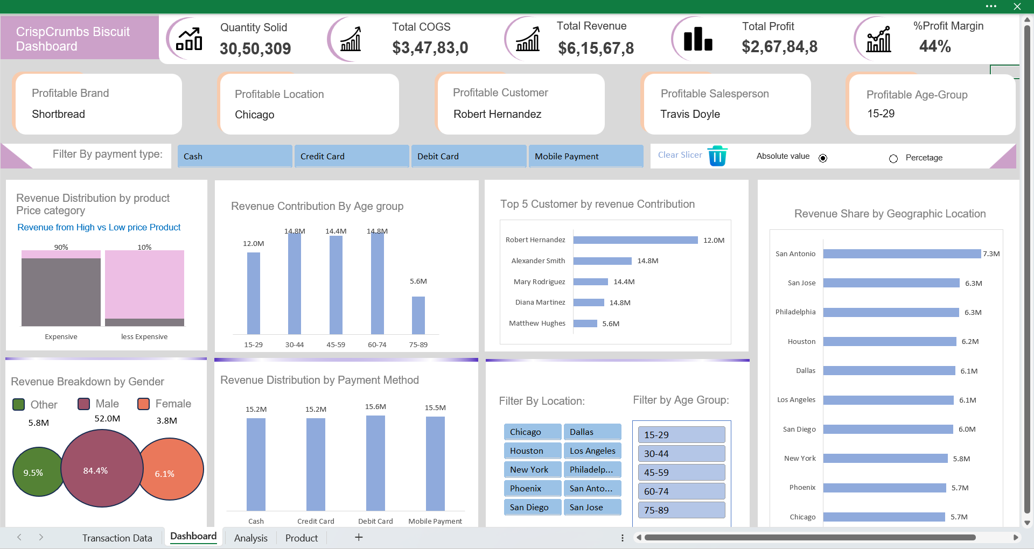

# Thank You